Launch the Web Clock from your Aesop Portal
To access the VeriTime Web-Clock from any Computer (as long as that Computer is within the School District’s IP-Address range) is as follows:
-Open up a Web-Browser window and goes to: www.frontlinek12.com/veritime
-Enter Aesop ID # (which is your phone-number) into the [ID] box.
-They then enter their Aesop PIN # into the [PIN] box.
-They then click on the [Login] button.
-Once logged in click on the [Time Clock] button to access the VeriTime Web Clock.
On this same site, you can click on the [Help] button to open up step-by-step instructions for any VeriTime process.
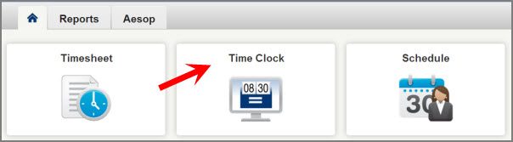

The Web Clock will launch as an overlay on top of your Aesop page. From this point, the use of the clock is exactly as it would be from a kiosk. When you’re done, click the X in the top-right corner of the overlay where indicated.

